Q1:

<!DOCTYPE html>

<html lang="en">

<head>

    <meta charset="UTF-8">

    <meta name="viewport" content="width=device-width, initial-scale=1.0">

    <meta http-equiv="X-UA-Compatible" content="ie=edge">

    <title>Website</title>

    <style>

        body{

            display: flex;

            justify-content: center;

            align-items: center;

            height: 97vh;

        }

        button{

            padding: 10px 30px;

            font-size: 26px;

            border-radius: 10px;

            border: solid rgb(109, 0, 0) 20px;

            background-color: aqua;

            font-weight: 700;

            font-family: 'Gill Sans', 'Gill Sans MT', Calibri, 'Trebuchet MS', sans-serif;

            cursor: pointer;

            transition: ease 200ms;

        }

        button:hover{

            background-color: red;

            border-color: rgb(0, 87, 87);

        }

        .red{

            background-color: red;

        }

        .blue{

            background-color: blue;

        }

        .green{

            background-color: green;

        }

        .yellow{

            background-color: yellow;

        }

        .purple{

            background-color: purple;

        }

        .orange{

            background-color: orange;

        }

    </style>

</head>

<body class="body">

        <button onclick="color()">

            Color Changer

        </button>

        <script>

            let count =-1;

            function color(){

                if(count == 6){

                    count = -1

                }

                count++

                if(count == 0){

                    document.querySelector("body").classList.add("red")

                } else if(count == 1){

                    console.log("flag")

                    document.querySelector("body").classList.add("blue")

                } else if(count == 2){

                    document.querySelector("body").classList.add("green")

                } else if(count == 3){

                    document.querySelector("body").classList.add("yellow")

                } else if(count == 4){

                    document.querySelector("body").classList.add("purple")

                } else if(count == 5){

                    document.querySelector("body").classList.add("orange")

                }

            }

        </script>

</body>

</html>

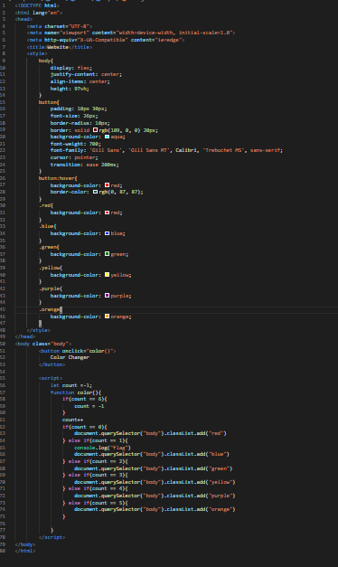

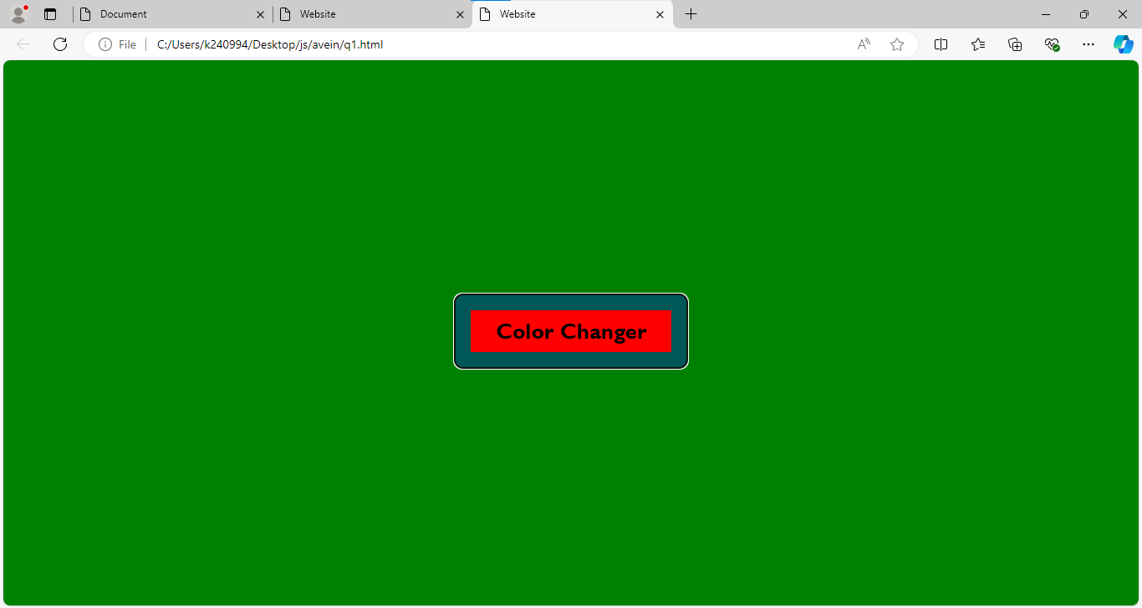

Q2:

<!DOCTYPE html>

<html lang="en">

<head>

    <meta charset="UTF-8">

    <meta name="viewport" content="width=device-width, initial-scale=1.0">

    <meta http-equiv="X-UA-Compatible" content="ie=edge">

    <title>Website</title>

    <style>

        body{

            display: flex;

            justify-content: center;

            align-items: center;

            height: 97vh;

        }

        button{

            padding: 10px 30px;

            font-size: 26px;

            border-radius: 10px;

            border: solid rgb(109, 0, 0) 20px;

            background-color: aqua;

            font-weight: 700;

            font-family: 'Gill Sans', 'Gill Sans MT', Calibri, 'Trebuchet MS', sans-serif;

            cursor: pointer;

            transition: ease 200ms;

        }

        button:hover{

            background-color: red;

            border-color: rgb(0, 87, 87);

        }

    </style>

</head>

<body class="body">

        <button onclick="alertrun()">

            Alert

        </button>

        <script>

            function alertrun(){

                alert("Click me again for this alert")

            }

        </script>

</body>

</html>

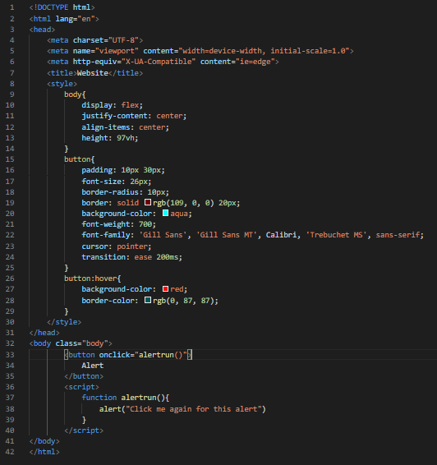

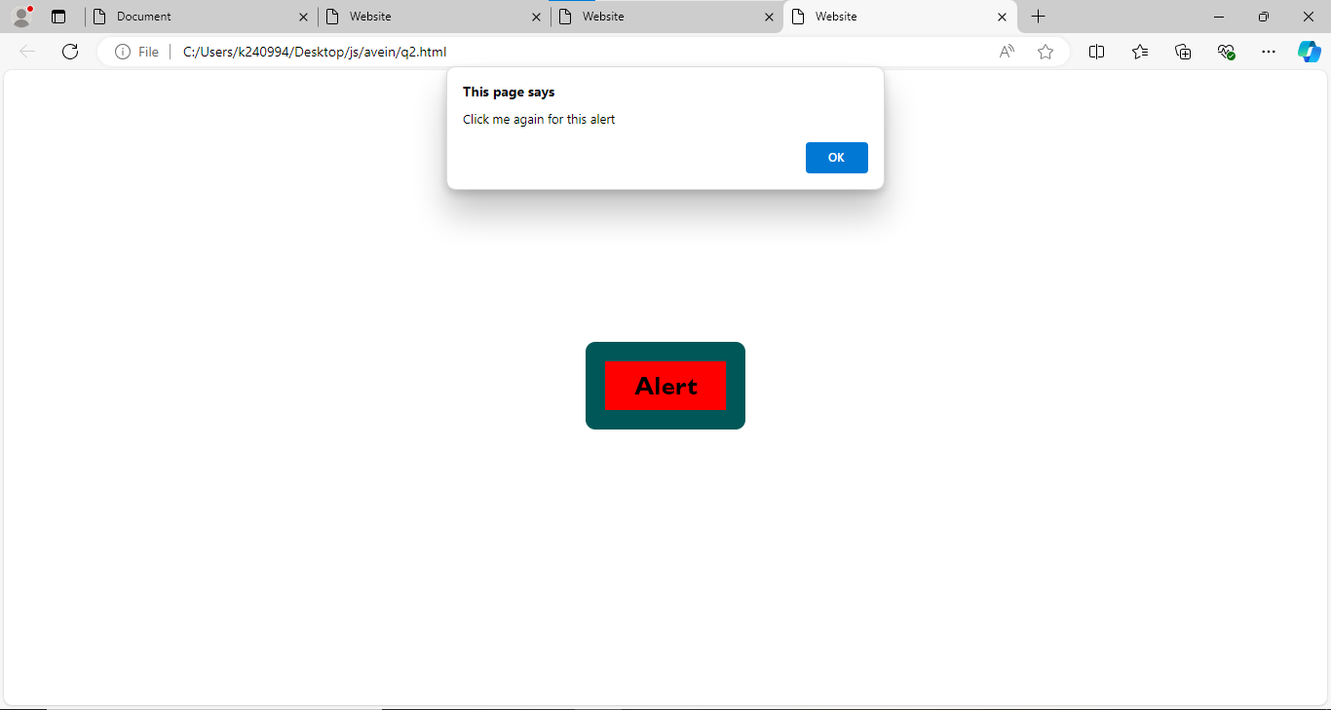

Q3:

<!DOCTYPE html>

<html lang="en">

<head>

    <meta charset="UTF-8">

    <meta name="viewport" content="width=device-width, initial-scale=1.0">

    <meta http-equiv="X-UA-Compatible" content="ie=edge">

    <title>Calculator</title>

</head>

<body>

    <div class="inputs">

        <input type="text" class="inp1">

        <input type="text" class="inp2">

        <button onclick="Calculate()">Add</button>

    </div>

    <script>

        function Calculate(){

            let num1 = parseFloat(document.querySelector(".inp1").value);

            let num2 = parseFloat(document.querySelector(".inp2").value);

            let sum = num1 + num2

            alert("the sum of the 2 numbers is: " + sum)

        }

    </script>

</body>

</html>

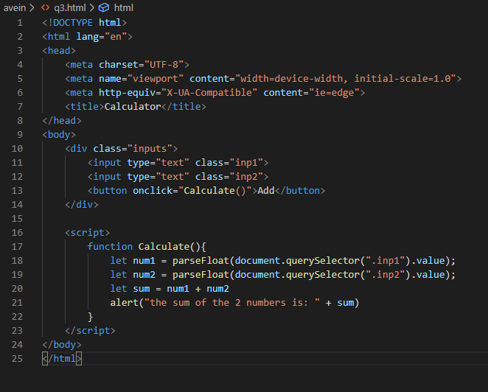

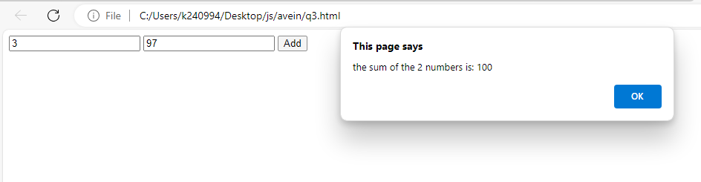

Q4:

<!DOCTYPE html>

<html lang="en">

<head>

    <meta charset="UTF-8">

    <meta name="viewport" content="width=device-width, initial-scale=1.0">

    <meta http-equiv="X-UA-Compatible" content="ie=edge">

    <title>Document</title>

</head>

<body>

    <div class="container">

        <h1 class="h1">Count has been pressed 0 Times</h1>

        <button onclick="clicked()">Press</button>

    </div>

    <script>

            let count = 0

        function clicked(){

            count ++

            document.querySelector("h1").innerHTML = "Count has been pressed " + count + " Times"

        }

    </script>

</body>

</html>

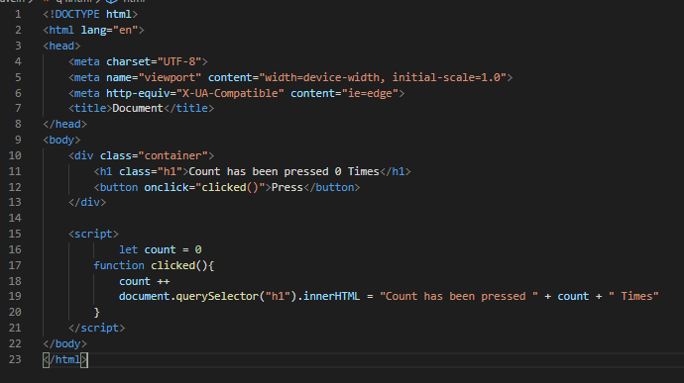

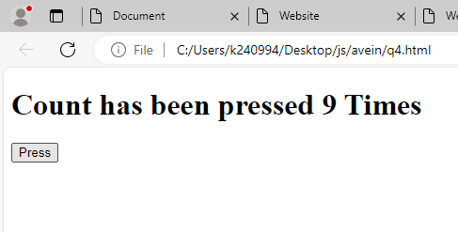

Q6:

<!DOCTYPE html>

<html lang="en">

<head>

    <meta charset="UTF-8">

    <meta name="viewport" content="width=device-width, initial-scale=1.0">

    <meta http-equiv="X-UA-Compatible" content="ie=edge">

    <title>Website</title>

    <style>

        body{

            display: flex;

            justify-content: center;

            align-items: center;

            height: 97vh;

        }

        button{

            padding: 10px 30px;

            font-size: 26px;

            border-radius: 10px;

            border: solid rgb(109, 0, 0) 20px;

            background-color: aqua;

            font-weight: 700;

            font-family: 'Gill Sans', 'Gill Sans MT', Calibri, 'Trebuchet MS', sans-serif;

            cursor: pointer;

            transition: ease 200ms;

        }

        button:hover{

            background-color: red;

            border-color: rgb(0, 87, 87);

        }

        .red{

            color: red;

        }

        .blue{

            color: blue;

        }

    </style>

</head>

<body class="body">

    <h1>This is a heading     </h1>

    <br>

        <button onclick="color()">

            Color Changer

        </button>

        <script>

            let count =-1;

            function color(){

                if(count == 2){

                    count = -1

                    document.querySelector("h1").classList.remove("red")

                    document.querySelector("h1").classList.remove("blue")

                }

                count++

                console.log(count)

                if(count == 0){

                    document.querySelector("h1").classList.add("red")

                } else if(count == 1){

                    console.log("flag")

                    document.querySelector("h1").classList.add("blue")

                }

            }

        </script>

</body>

</html>

